**Name:** V Venkata Sri Prasad

**Batch:** Data Engineering

**Date:** 10/02/2024 – (Day 17)

Topics:

1. Spark SQL - Creating databases, tables and views
2. Spark SQL - Transformations such as Filter, Join, Simple Aggregations, GroupBy, Window functions etc.
3. Spark SQL - Creating local and temporary views

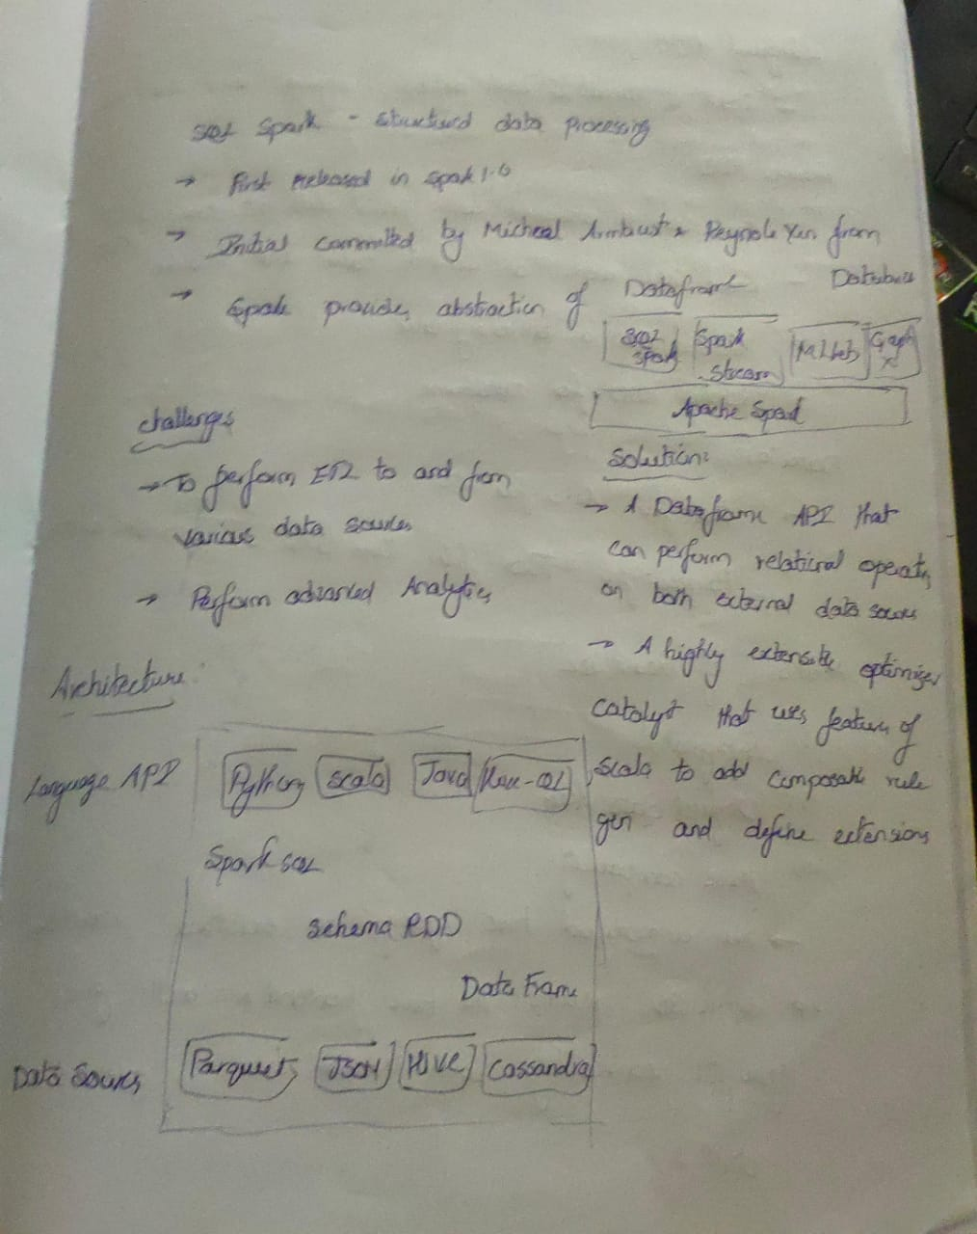

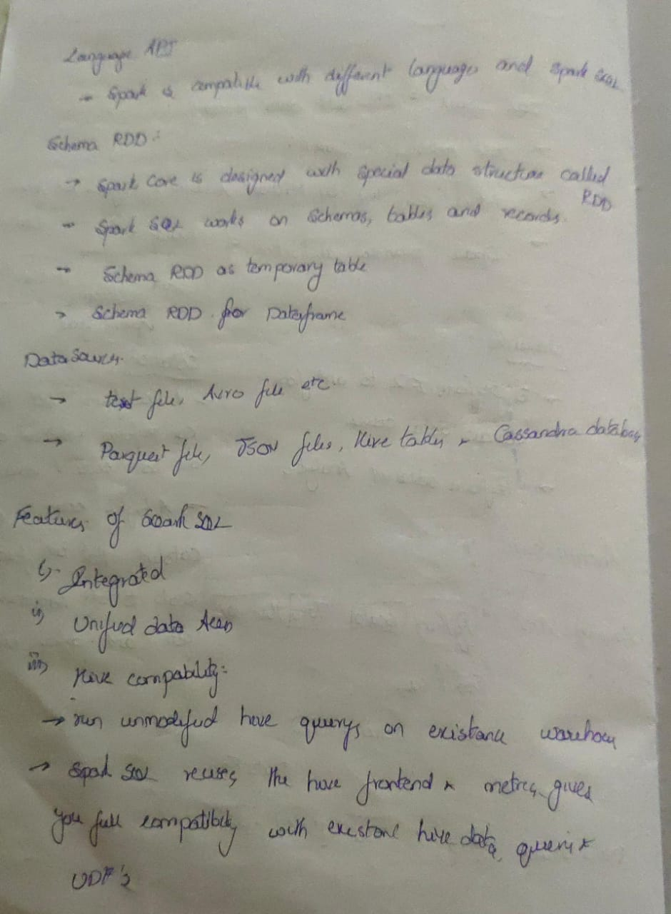

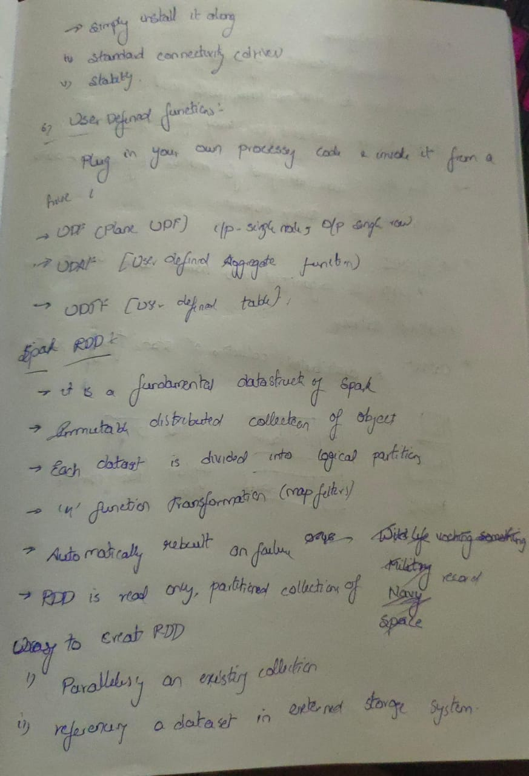

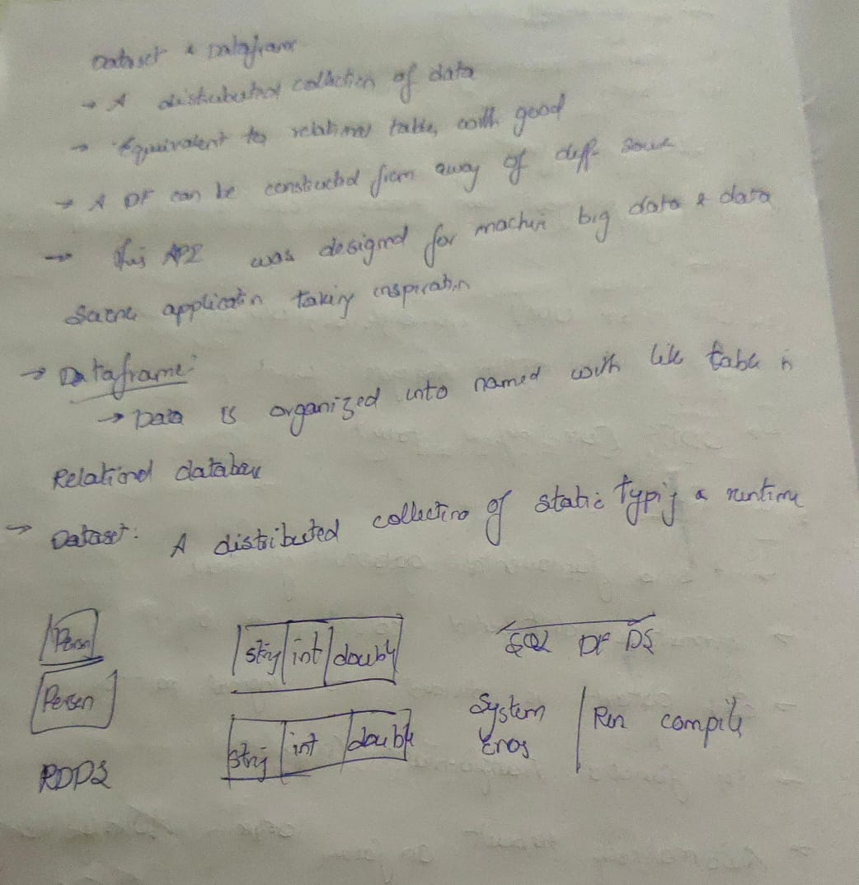

Spark SQl

Creating a Session and Creating a Database

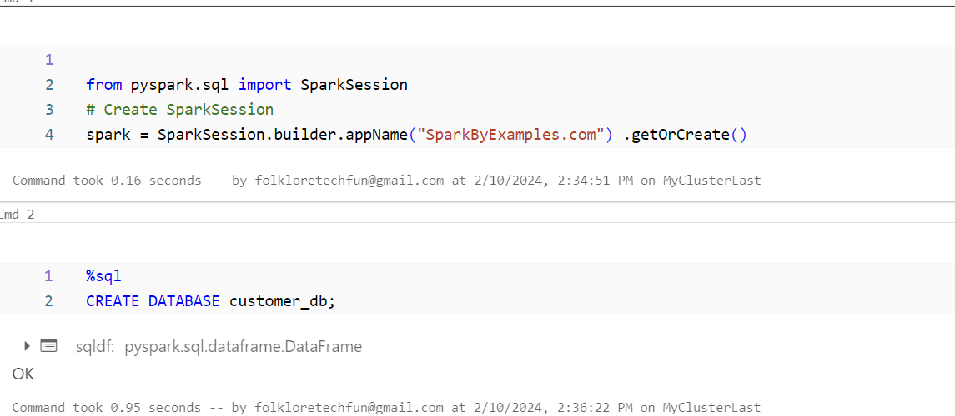

If Not Exists

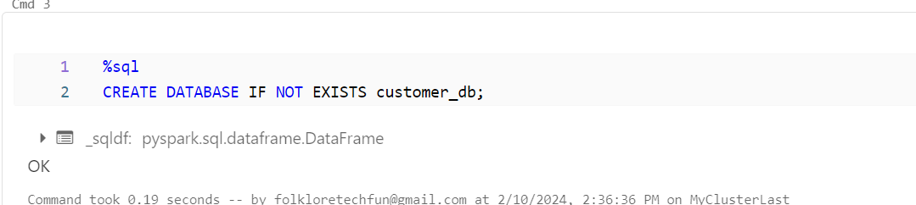

If not exists comment

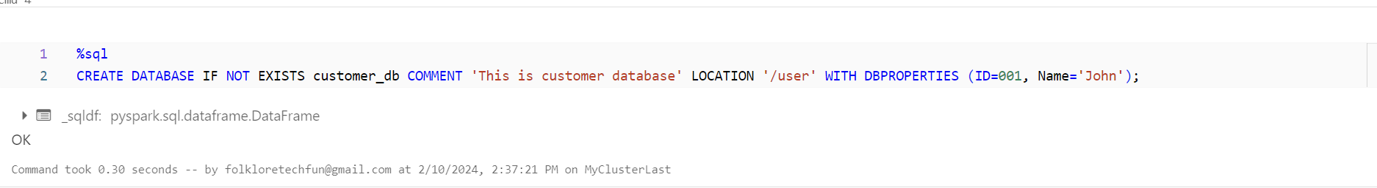

Describe

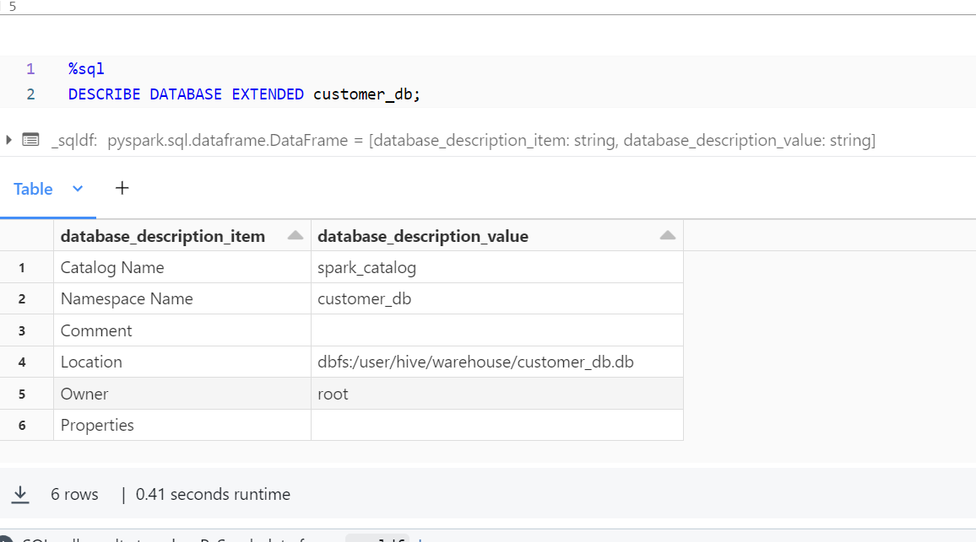

Creating Data Frame

And Creating Temporary view

